|  |
| --- |
|  |
| APP-6 SVG Symbology Filename Convention |
| JCSys/C036/134/1.1 |
|  |
| **Version 1.1**  **Paul Twornicki** |
| 21 Sep 16 |

|  |
| --- |
| *ISO9001:2008*  *FS532684*  JCSys Ltd Quality System Registered to ISO9001:2008  © 2016 Crown Copyright |

# 

# INTRODUCTION

* 1. The filename convention used for APP-6(D) Scalable Vector Graphic (SVG) files is described below. The convention is based on the Symbol Identification Code (SIDC) rules detailed in Annex A of APP-6(D), which describes the codification of the individual symbol components used to present symbology using the building block approach.

SVG File Naming Convention

All files are named according to select portions of the 20-character Symbol Identification Code (SIDC) in order to give them proper uniqueness and consistency.

For symbol assembly purposes, the following SIDC positions are used to determine what icons are to be used to create the proper symbol layers. **Note:** all of these icon layers do not apply to all Symbol Sets.

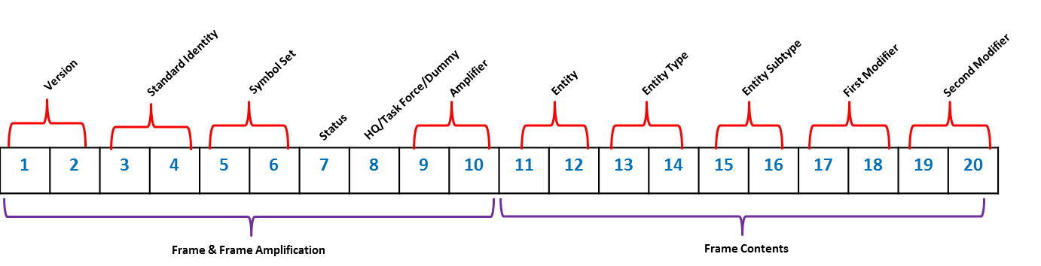

Figure APP-6(D) SIDC Breakdown

Frame (*Folder: Frames - Characters: 7*): Uses SIDC positions 3-7 with an underscore ( _ ) after position 3 and after position 6.

* Reality example: 0_100_0.svg
* Planned/Anticipated/Suspect example: 0_100_1.svg
* Purple filled frames for Civilian units, Equipment, and Installations have a ‘c’ at the end of the filename.
  + example: 0_100_0c.svg

Main Icon (*Folder: Chapters\XXX - Characters: 8*): Uses SIDC positions 5-6 and 11-16

* For full-frame main icons (main icons that touch the frame), there is an additional suffix depending on the frame that the icon must touch:
  + _0 = Unknown
  + _1 = Friend
  + _2 = Neutral
  + _3 = Hostile

Modifier 1 (*Folder: Chapters\XXX\mod1 - Characters: 5*): Uses SIDC positions 5-6 and 17-18 along with the number 1 at the end

Modifier 2 (*Folder: Chapters\XXX\mod2 - Characters: 5*): Uses SIDC positions 5-6 and 19-20 along with the number 2 at the end

Echelon (*Folder: Echelon - Characters: 3*): Uses SIDC positions 4 and 9-10.

Amplifier (Mobility/Towed Array/Leadership) *(Folder: Amplifier - Characters: 3*): Uses SIDC positions 4 and 9-10

Headquarters (HQ)/Task Force (TF)/Feint/Dummy (FD) (*Folder: HQTFFD - Characters: 4*): Uses SIDC positions 4-6 and position 8.

Status/Operational Condition Amplifier (OCA) (*Folder: OCA - Characters: 1 or 6*, depending on style): Since, the standard allows for two styles of these, file names vary based on which style is considered.

* Default version – Uses SIDC position 7
  + 1 = Damaged (/)
  + 2 = Destroyed ( X )
* Alternate version (coloured bar) – Uses SIDC positions 3-7 along with an additional value of 2 at the end.

**Note:** When implementing OCA, amplifiers, and HQTFFD symbols that require a ‘dotted’ frame version, the following logic shall be used:

Second position of the Standard Identity is:

0 (Pending) = 1 (Unknown)

2 (Assumed Friend) = 3 (Friend)

5 (Suspect/Joker) = 6 (Hostile/Faker)

Internal SVG Naming Convention

Within each SVG file the following standardization has been applied:

1. The symbol’s layer ID contains the version of the image, starting at 1.0. When a minor change is made to the symbol the minor version will be increased by 1 (1.1, 1.2, etc.). If the symbol is changed, in that it no longer looks similar to the previous version, then the major version will be increased by 1 (2.0, 3.0, etc.)
2. g_ID’s have been created for the ‘octagon’ and the type of symbol (example: a Main icon will have a g_ID of “main”, a Mod1 icon will have a g_ID of “mod1”). The following g_IDs are used within the entire SVG set; main, mod1, mod2, amplifier, echelon, frame, oca, and HQTFFD.
3. For Control Measures, a g_ID has been created for the template, the actual control measure (g_ID = “main” for consistency in code) and example.
4. **Generic font usage**: This allows for any OS to properly display text within a symbol without the concern of having to install a particular font.
5. All files have a font as font-family="sans-serif" listed in the XML of the SVG file. (ex: Arial).

SVG Configuration Management

1. The APP-6(D) NATO JOINT MILITARY SYMBOLOGY catalogue will undergo periodic version and revision updates. To ensure the symbols used are contained within the specified version of the Standard, the edition and version of APP-6 will be included within the XML comments of the SVG as part of the comment on line two of the background XML data. See example below.

|  |  |
| --- | --- |
| **Example of a completed symbol with several ‘parts’ combined into one SVG file** | |
|  | <?xml version="1.0" encoding="utf-8"?>  <!-- APP-6(D)(1) Generator: Adobe Illustrator 12.0.1, SVG Export Plug-In . SVG Version: 6.00 Build 51448) -->  <!DOCTYPE svg PUBLIC "-//W3C//DTD SVG 1.1//EN" "http://www.w3.org/Graphics/SVG/1.1/DTD/svg11.dtd" [  <!ENTITY ns_svg "http://www.w3.org/2000/svg">  <!ENTITY ns_xlink "http://www.w3.org/1999/xlink">  ]>  <svg version="1.1" id="Version_1.0" xmlns="&ns_svg;" xmlns:xlink="&ns_xlink;" width="612" height="792" viewBox="0 0 612 792"  overflow="visible" enable-background="new 0 0 612 792" xml:space="preserve">  <g id="frame">  <g id="XMLID_33_">  <g>  <g id="XMLID_3_">  <g>  <polygon fill="#80E0FF" points="432.44,323.5 432.44,469.5 306,542.5 179.56,469.5 179.56,323.5 306,250.5 "/>  </g>  <g>  <polygon fill="none" stroke="#000000" stroke-width="5" points="432.44,323.5 432.44,469.5 306,542.5 179.56,469.5  179.56,323.5 306,250.5 "/>  </g>  </g>  </g>  </g>  </g>  <g id="octagon">  <polygon fill="none" stroke="#0000FF" stroke-width="2" points="305,516.5 218.733,480.768 183,394.5 218.733,308.233 305,272.5  391.268,308.233 427,394.5 391.268,480.768 "/>  <line fill="none" stroke="#0000FF" stroke-width="2" x1="202.5" y1="345.7" x2="407.5" y2="345.7"/>  <line fill="none" stroke="#0000FF" stroke-width="2" x1="202.5" y1="443.3" x2="407.5" y2="443.3"/>  </g>  <g id="main">  <line fill="none" stroke="#000000" stroke-width="5" x1="278.5" y1="441.17" x2="331.498" y2="441.17"/>  <line fill="none" stroke="#000000" stroke-width="5" x1="278.5" y1="401.646" x2="331.498" y2="401.646"/>  <line fill="none" stroke="#000000" stroke-width="5" x1="304.999" y1="352.291" x2="304.999" y2="441.17"/>  <polyline fill="none" stroke="#000000" stroke-width="5" points="278.897,366.419 304.999,351.17 331.5,366.419 "/>  </g>  <g id="mod1">  <circle cx="305" cy="319.5" r="17.5"/>  </g>  <g id="mod2">  <text transform="matrix(1 0 0 1 231.665 491.5146)" font-family="sans-serif" font-size="60">OF-2</text>  </g>  <g id="amplifier">  <line fill="none" stroke="#000000" stroke-width="5" x1="306.433" y1="228.333" x2="173.294" y2="305"/>  <line fill="none" stroke="#000000" stroke-width="5" x1="304.433" y1="228" x2="436.706" y2="305"/>  </g>  <g id="HQTFFD">  <line fill="none" stroke="#000000" stroke-width="5" stroke-dasharray="17" x1="306.433" y1="209.333" x2="173.294" y2="286"/>  <line fill="none" stroke="#000000" stroke-width="5" stroke-dasharray="17" x1="304.433" y1="209" x2="436.706" y2="286"/>  </g>  </svg> |